Welcome to A Level Biology

Biology is the study of life. It will enable you to develop a vast array of skills and acquire knowledge about the natural world and all the living things within it. Gaining an A Level in this subject opens up a vast range of opportunities for both university degrees and career options.

At Crompton House Sixth Form, we study the Eduqas A Level Biology qualification. During the course you will cover a wide range of topics. Our qualification is made up of three themed components which are examined at the end of the second year of study.

Should you wish to purchase a textbook or revision guide for A Level Biology, there are several we can recommend.

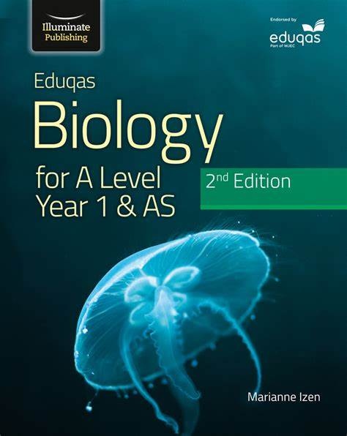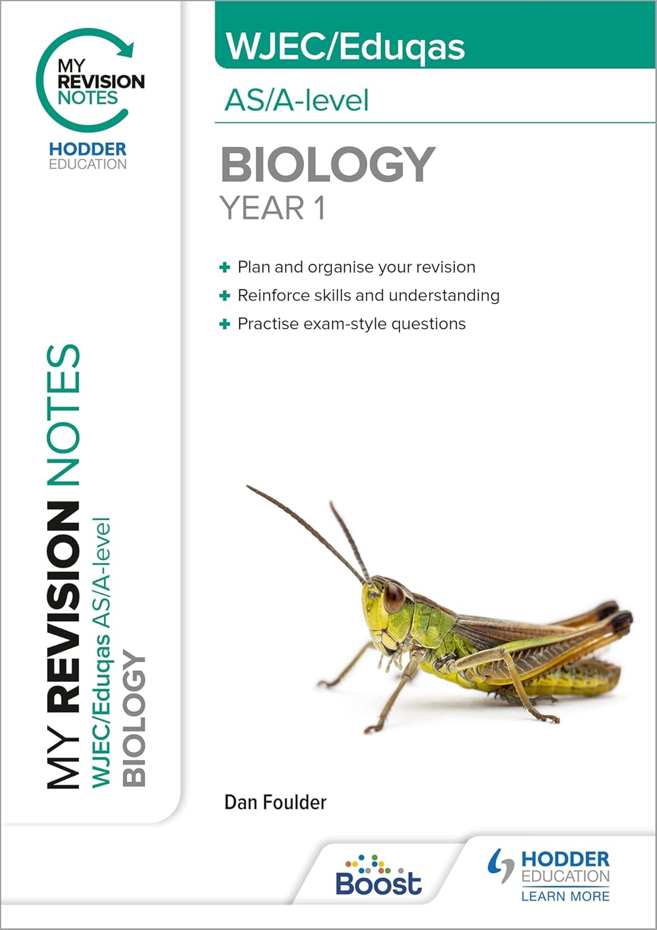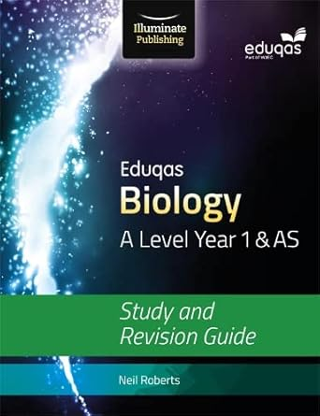

# Course Content

There is a body of biological knowledge which is essential for understanding many other biological concepts you may come across and could be assessed in any of the three components. These initial topics are called ‘Core Concepts’ and build on your knowledge of Biology from GCSE. We start off the A Level course by studying these in the Autumn term of Year 12 before moving on to the topics that will appear in the final exams.

## Core concepts

You will cover a variety of topics here which will help give you the foundation you need to understand the more complex topics in the other components.

* Biological molecules
* Cell structure and function
* Transport into and out of the cell
* Enzymes
* Nucleic acids
* Cell division

## Component 1: Energy for Life

This component covers the biochemistry of ATP production, respiration, and photosynthesis.

The topics in this component are:

* ATP
* Photosynthesis
* Microbiology
* Population size and
* Human impact on the environment

## Component 2: Continuity of life

This component covers some reproduction in animals and plants and how knowledge about DNA and gene technology is making some huge advances possible.

* Biodiversity and classification
* Cell division
* Sexual reproduction in humans
* Sexual reproduction in plants
* Inheritance
* Variation and evolution
* Application of reproduction and genetics

## Component 3: Requirements for Life

This component looks at physiological systems. It also contains a choice of one option from three. The topics in this component are:

* Adaptations to gas exchange
* Adaptations to transport
* Adaptations for nutrition
* Homeostasis and the kidney
* The nervous system

There is also a choice of choice of one option from three:

* Immunology and disease
* Human musculoskeletal anatomy
* Neurobiology and behaviour

At CHS we typically teach the Immunology and Disease option topic, however students who study PE may choose to independently study the Human Musculoskeletal Anatomy topic. Similarly those interested in neuroscience and biopsychology may choose to independently study the Neurobiology and Behaviour option. Of course, resources and support are available for students who would like to study one of these options in addition to the Immunology and Disease topic.

# Preparation for A Level

To prepare for studying A Level Biology, you should review your notes **from GCSE** on the topics below, then attempt the exam questions.

Please complete the questions using the 3-pen method:

* First colour – attempt the question from memory.
* Second colour – add to your answer using your notes, look particularly at your use of key words.
* Third colour – use the mark scheme to correct your work.

# Topic list

* Biological molecules
  + Proteins
  + Lipids
  + Carbohydrates
* Cell structure
  + Prokaryotic and eukaryotic cells
  + Function of organelles: mitochondria, ribosomes, nucleus, chloroplast, vacuole
  + Studying cell structure using a microscope
  + Specialised cells in animals and plants
* Cell transport
  + Diffusion
  + Osmosis
  + Active transport
  + The role of the cell membrane
* Exchange
  + Structure of the thorax
  + Breathing in and out
  + Gas exchange in plants
  + Surface area to volume ratio
* Cell division
  + Mitosis
  + Meiosis
  + DNA and chromosome structure
  + DNA mutations

If you studied Combined Biology for GCSE, you would find it useful to develop your knowledge of DNA structure and protein synthesis. There are plenty of YouTube tutorials (or use GCSEPod or Seneca Learning) that will give you an overview.

**Q1.**

Meiosis and mitosis are different types of division in human cells. Compare the two processes by referring to where each takes place and the kind of products that are made.

_______________________________________________________________________

_______________________________________________________________________

_______________________________________________________________________

_______________________________________________________________________

_______________________________________________________________________

_______________________________________________________________________

_______________________________________________________________________

_______________________________________________________________________

_______________________________________________________________________

_______________________________________________________________________

_______________________________________________________________________

**(Total 6 marks)**

**Q2.**

Some students set up an experiment using osmosis to find the concentration of sucrose solution in potato cell sap. They used discs of potato cut to the same size and weighing approximately 10 g. The discs were put into each of five beakers.

(a)     (i)      After two hours they reweighed the discs after carefully blotting them first. Why did the students blot the potato before weighing it?

______________________________________________________________

______________________________________________________________

**(1)**

(ii)     Their results are shown in the table below.

|  |  |  |  |  |  |
| --- | --- | --- | --- | --- | --- |
|  | **Beaker 1** | **Beaker 2** | **Beaker 3** | **Beaker 4** | **Beaker 5** |
| Final mass in g | 13.0 | 12.2 | 9.0 | 7.9 | 7.3 |
| Initial mass in g | 10.0 | 10.6 | 10.0 | 10.1 | 10.4 |

The students calculated the % gain or loss in mass of potato. Complete this table of results for Beakers 2, 4 and 5.

|  |  |  |  |  |
| --- | --- | --- | --- | --- |
| **Beaker 1** | **Beaker 2** | **Beaker 3** | **Beaker 4** | **Beaker 5** |
| 13 – 10.0 = 3.0 |  | 9.0 – 10.0 =  –1.0    = –10% |  |  |
| Gain in mass = 30% |  | Loss in mass = 10% |  |  |

**(3)**

(b)     (i)      Draw a graph of % Gain or Loss in mass against sucrose concentration.

**(3)**

(ii)     Use the graph to find the concentration of potato cell sap.

Concentration of cell sap = _____________________ % sucrose solution

**(1)**

(iii)     Explain in terms of osmosis how you chose this value.

______________________________________________________________

______________________________________________________________

______________________________________________________________

**(2)**

**(Total 10 marks)**

**Q3.**

**Figure 1** shows an image of a small section of DNA.

**Figure 2** shows the structure of a small section of DNA.

**Figure 1**                                                              **Figure 2**

© Svisio/iStock/Thinkstock

(a)     What is Part **B**?

___________________________________________________________________

___________________________________________________________________

**(1)**

(b)     In **Figure 1** the structure of DNA shows four different bases.

There are four different bases and they always pair up in the same pairs.

Which bases pair up together?

___________________________________________________________________

**(1)**

(c)     Syndrome H is an inherited condition.

People with syndrome H do **not** produce the enzyme IDUA.

**Figure 3** shows part of the gene coding for the enzyme IDUA.

Strand **K** shows a mutation in the DNA which has caused syndrome H.

The enzyme IDUA helps to break down a carbohydrate in the human body.

The enzyme IDUA produced from Strand **K** will not work.

Explain how the mutation could cause the enzyme **not** to work.

___________________________________________________________________

___________________________________________________________________

___________________________________________________________________

___________________________________________________________________

___________________________________________________________________

___________________________________________________________________

___________________________________________________________________

___________________________________________________________________

___________________________________________________________________

___________________________________________________________________

**(5)**

(d)     A recessive allele causes syndrome H.

A heterozygous woman and a homozygous recessive man want to have a child.

Draw a Punnett square diagram to determine the probability of the child having syndrome H.

Identify any children with syndrome H.

Use the following symbols:

**A** = dominant allele

**a** = recessive allele

Probability = ___________________ %

**(5)**

**(Total 12 marks)**

**Q4.**

**Figure 1** shows a model representing the human breathing system.

The different parts of the model represent different parts of the human breathing system.

(a)     (i)      Which part of the human breathing system does the flexible rubber sheet represent?

______________________________________________________________

**(1)**

(ii)     Explain why the balloons inflate when the flexible rubber sheet is pulled down.

______________________________________________________________

______________________________________________________________

______________________________________________________________

______________________________________________________________

______________________________________________________________

______________________________________________________________

**(3)**

(b)     (i)      During breathing, oxygen moves into the blood.

Explain how oxygen moves into the blood.

______________________________________________________________

______________________________________________________________

______________________________________________________________

______________________________________________________________

**(2)**

(ii)     **Figure 2** shows a fish head and gill.

Fish absorb oxygen from the water. Oxygen is absorbed through the gills of the fish.

Explain **one** way in which the gills are adapted for rapid absorption of oxygen.

______________________________________________________________

______________________________________________________________

______________________________________________________________

______________________________________________________________

**(2)**

**(Total 8 marks)**

**Q5.**

The diagram shows a plant leaf during photosynthesis.

(a)     Name:

(i)      gas **X**; _______________

(ii)     gas **Y**. _______________

**(2)**

(b)     Why is sunlight necessary for photosynthesis?

___________________________________________________________________

___________________________________________________________________

**(1)**

(c)     Some of the sugars produced by photosynthesis are stored as starch in the roots.  
Explain, as fully as you can, why it is an advantage to the plant to store carbohydrate as starch rather than as sugar.

___________________________________________________________________

___________________________________________________________________

___________________________________________________________________

___________________________________________________________________

___________________________________________________________________

___________________________________________________________________

**(3)**

**(Total 6 marks)**

**Q6.**

The black pigment in human skin and eyes is called melanin. Production of melanin is controlled by a single pair of genes. A person who is homozygous for a recessive allele of the gene has no melanin and is said to be albino.

(a)     A man is albino. His wife is heterozygous for the melanin-producing allele.

(i)      The fertilised egg cell produced by the couple divides to form two cells.

         Name the process of cell division involved.

______________________________________________________________

**(1)**

(ii)     How many albino genes would there be in each of these two cells?

______________________________________________________________

         Explain your answer.

______________________________________________________________

______________________________________________________________

______________________________________________________________

**(3)**

(b)     (i)      Albino people are more likely than people with melanin to suffer mutations that cause cancer in their skin. Suggest why albino people have an increased chance of mutation in their skin cells.

______________________________________________________________

______________________________________________________________

**(1)**

(ii)     Sometimes, mutation in skin cells leads to cancers in other organs, such as the liver.

         Explain how.

______________________________________________________________

______________________________________________________________

______________________________________________________________

______________________________________________________________

**(2)**

**(Total 7 marks)**

**Q7.**

A student prepared some onion cells.

The student viewed the onion cells using a light microscope.

This is the method used.

1. Cut an onion into pieces using a sharp knife.

2. Peel off a thin layer of onion epidermis from one piece of onion.

3. Place the onion epidermis onto a microscope slide in a single flat layer.

4. Add three drops of iodine solution.

5. Slowly lower a cover slip at an angle onto the onion epidermis.

6. Place the slide on the stage of the microscope.

(a)  The table below shows a risk assessment for this experiment.

Complete the table.

|  |  |  |
| --- | --- | --- |
| **Hazard** | **Risk** | **Plan to minimise risk** |
| Iodine solution is an irritant | May cause allergic reaction or skin rash |  |
| Sharp knife |  |  |

**(2)**

(b)  Give a reason for each of the following steps in the method.

A **thin layer** of onion epidermis is used.

___________________________________________________________________

___________________________________________________________________

___________________________________________________________________

**Iodine solution** is added to the onion epidermis.

___________________________________________________________________

___________________________________________________________________

___________________________________________________________________

The cover slip is lowered onto the onion epidermis **at an angle**.

___________________________________________________________________

___________________________________________________________________

___________________________________________________________________

**(3)**

**Figure 1** shows what the student saw under the microscope at a magnification of ×400.

**Figure 1**

(c)  The length of cell **Z** in **Figure 1** is 4.8 cm.

Calculate the real length of cell **Z**.

Give your answer in micrometres (µm).

___________________________________________________________________

___________________________________________________________________

___________________________________________________________________

___________________________________________________________________

___________________________________________________________________

___________________________________________________________________

___________________________________________________________________

___________________________________________________________________

___________________________________________________________________

___________________________________________________________________

___________________________________________________________________

___________________________________________________________________

Real length of cell **Z** = _______________µm

**(5)**

**Figure 2** shows the student’s drawing of **Figure 1**.

**Figure 2**

(d)  Give **two** ways the student could improve the drawing in **Figure 2**.

1  _________________________________________________________________

___________________________________________________________________

2  _________________________________________________________________

___________________________________________________________________

**(2)**

(e)  Onion cells can be seen using an electron microscope.

Give **two** ways onion cells would look different when seen using an electron microscope.

1  _________________________________________________________________

___________________________________________________________________

2  _________________________________________________________________

___________________________________________________________________

**(2)**

**(Total 14 marks)**

**Q8.**

(a)     How many pairs of chromosomes are there in a body cell of a human baby?

___________________________________________________________________

**(1)**

(b)     Place the following in order of size, **starting with the smallest,** by writing  
numbers **1** – **4** in the boxes underneath the words.

**(1)**

(c)     For a baby to grow, its cells must develop in a number of ways.

          Explain how each of the following is part of the growth process of a baby.

(i)      Cell enlargement

______________________________________________________________

**(1)**

(ii)     The process of cell division by mitosis

______________________________________________________________

______________________________________________________________

______________________________________________________________

______________________________________________________________

______________________________________________________________

______________________________________________________________

**(3)**

(d)     Why is cell specialisation (differentiation) important for the development and growth of a healthy baby from a fertilised egg?

___________________________________________________________________

___________________________________________________________________

**(2)**

**(Total 8 marks)**

**Q9.**

Plants need chemical energy for respiration and for active transport.

(i)      Write a balanced chemical equation which represents the process of respiration in plants.

___________________________________________________________________

**(2)**

(ii)      Describe the process of active transport in the root hair cells of plants.

___________________________________________________________________

___________________________________________________________________

___________________________________________________________________

___________________________________________________________________

___________________________________________________________________

___________________________________________________________________

___________________________________________________________________

___________________________________________________________________

___________________________________________________________________

___________________________________________________________________

**(3)**

**(Total 5 marks)**

**Q10.**

The photograph shows a red blood cell in part of a blood clot. The fibres labelled **X** are produced in the early stages of the clotting process.

(a)     Suggest how the fibres labelled **X** help in blood clot formation.

___________________________________________________________________

**(1)**

(b)     The average diameter of a real red blood cell is 0.008 millimetres.  
On the photograph, the diameter of the red blood cell is 100 millimetres.

Use the formula to calculate the magnification of the photograph.

Diameter on photograph = Real diameter × Magnification

___________________________________________________________________

___________________________________________________________________

___________________________________________________________________

Magnification = _______________________________

**(2)**

(c)     Some blood capillaries have an internal diameter of approximately 0.01 millimetres.

(i)      Use information given in part (b) to explain why only one red blood cell at a time can pass through a capillary.

______________________________________________________________

**(1)**

(ii)     Explain the advantages of red blood cells passing through a capillary one at a time.

______________________________________________________________

______________________________________________________________

______________________________________________________________

______________________________________________________________

______________________________________________________________

______________________________________________________________

**(3)**

**(Total 7 marks)**

**Q11.**

(a)     The concentration of sulfate ions was measured in the roots of barley plants and in the water in the surrounding soil.

          The table shows the results.

|  |  |
| --- | --- |
|  | **Concentration of sulfate ions in mmol per dm3** |
| Roots of barley plants | 1.4 |
| Soil | 0.15 |

          Is it possible for the barley roots to take up sulfate ions from the soil by diffusion?

          Draw a ring around your answer. **Yes / No**

          Explain your answer.

___________________________________________________________________

___________________________________________________________________

___________________________________________________________________

___________________________________________________________________

**(2)**

(b)     Some scientists investigated the amounts of sulfate ions taken up by barley roots in the presence of oxygen and when no oxygen was present.

          The graph below shows the results.

(i)      The graph shows that the rate of sulfate ion uptake between 100 and 200 minutes, **without** oxygen, was 0.4 arbitrary units per minute.

         The rate of sulfate ion uptake between 100 and 200 minutes, **with** oxygen, was greater.

         How much greater was it? Show clearly how you work out your answer.

______________________________________________________________

______________________________________________________________

______________________________________________________________

Answer __________ arbitrary units

**(2)**

(ii)     The barley roots were able to take up more sulfate ions with oxygen than without oxygen.

         Explain how.

______________________________________________________________

______________________________________________________________

______________________________________________________________

______________________________________________________________

______________________________________________________________

______________________________________________________________

**(3)**

**(Total 7 marks)**

**Q12.**

Spiders produce a protein thread which is extremely strong compared to man-made fibres of the same diameter.

          Explain how genes control the way the protein is made in the spider’s body.

_______________________________________________________________________

_______________________________________________________________________

_______________________________________________________________________

_______________________________________________________________________

_______________________________________________________________________

**(Total 4 marks)**

**Q13.**

 The villi of the small intestine absorb the products of digestion.

The diagram shows two villi. It also shows parts of some of the surface cells of a villus, as seen with an electron microscope.

Describe and explain how the villi are adapted to maximise the rate of absorption  
of the products of digestion.

_______________________________________________________________________

_______________________________________________________________________

_______________________________________________________________________

_______________________________________________________________________

_______________________________________________________________________

_______________________________________________________________________

_______________________________________________________________________

_______________________________________________________________________

_______________________________________________________________________

_______________________________________________________________________

_______________________________________________________________________

_______________________________________________________________________

**(Total 5 marks)**

**Q14.**

Describe the roles of the liver and the pancreas in the digestion of fats.

_______________________________________________________________________

_______________________________________________________________________

_______________________________________________________________________

_______________________________________________________________________

_______________________________________________________________________

_______________________________________________________________________

_______________________________________________________________________

_______________________________________________________________________

**(Total 5 marks)**

**Q15.**

Most people have a gene which produces a protein called CFTR that enables the cells lining the lungs to work efficiently. In people suffering from cystic fibrosis this gene is faulty; it produces a protein which lacks just one of the 1480 amino acids found in CFTR.

(i)      Name the molecule which carries the genetic information for producing proteins such as CFTR.

___________________________________________________________________

**(1)**

(ii)      Explain how this molecule is responsible for the structure of proteins such as CFTR.

___________________________________________________________________

___________________________________________________________________

___________________________________________________________________

___________________________________________________________________

___________________________________________________________________

___________________________________________________________________

**(3)**

**(Total 4 marks)**

The mark scheme for these questions can be found at <https://EOWEOUH.exampro.net> or by scanning the QR code below.

This work will be checked in your first Biology lesson in September – please bring it, completed and marked, to your first day of Sixth Form!